**SIR APOLLO**

**MID TERM III EXAMINATION 2023**

**TOP CLASS: (5 – 6 YEARS)**

**LEARNING AREA 5: LANGUAGE DEVELOPMENT II**

**My name is: ……………………………………………………………….**

**My School is: …………………………………….………………………..**

**I am in: ………………………………..…………………………….…………………..**

1. 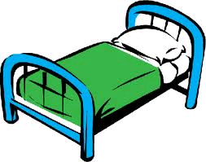**Write the last sound.**

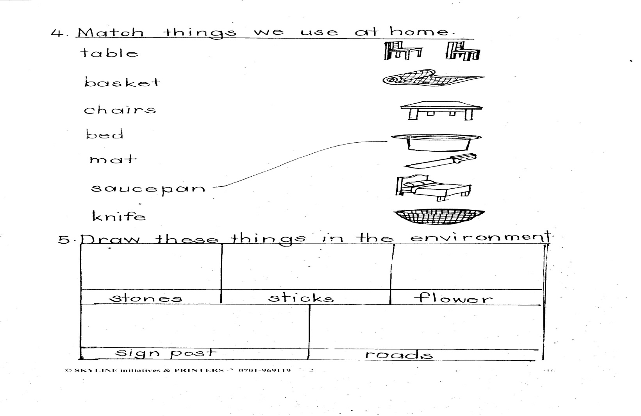

be ___ bo___ ma___

1. **Fill in the missing syllables.**

da de di ____ du

ta te ___ to ___

1. **Form words.**

b k

__________________________

m o o n

__________________________

g d

__________________________

__________________________

p l

1. **Circle words with sound ee.**
   1. The sheep is big.
   2. I can see a dog.
   3. She has three books.
   4. I have a sweet.
2. **Name the pictures.**

|  |  |  |  |
| --- | --- | --- | --- |
| D:\Local Disk F\New folder\SECRETARY\NEW PICS\MY PHOTOS\PICTURES\LISA EVE\school bag 1.jpg |  |  |  |
|  |  |  |  |

1. **Make sentences using That is a………...**

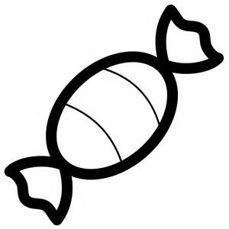 _______________________________

_______________________________

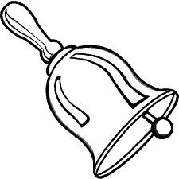 _______________________________

__________________________________

1. **Write the first syllable for the picture.**

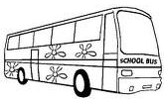

___________

___________

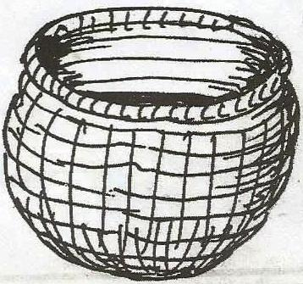

________

1. **Write a sentence for the word.**

banana ________________________________

stool ____________________________________

bottle __________________________________

1. 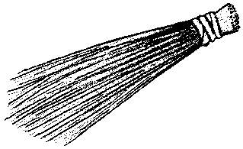C:\Program Files\Microsoft Office\CLIPART\PUB60COR\J0101980.WMF**Fill in the missing sound.**

b__oom tr_ _

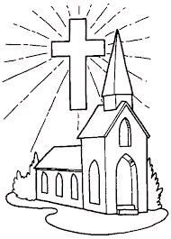

chur__ __ m__ __n

1. **Read the story and answer the questions.**

My name is Nakuya. I am five years old. I am in Top class. I have a blue dress and a black bag. My teacher’s name is Rose. I love my teacher so much.

**Questions**

1. In which class is Nakuya?

_______________________________________

1. How old is Nakuya?

_______________________________________

1. Who is Nakuya’s teacher?

________________________________________

1. What colour is Nakuya’s bag?

_________________________________________

1. Draw Nakuya with her bag.

***END***